
Nile Valley Consistory of Ancient and Accepted Scottish-Rite
Commander in Chief
ILL:. B:. Gerald Walker 33°
Deputy, Commander
ILL:. B:. Roderick DeSouza 33°
Officers to be commissioned
1st Lt. Commander
2nd Lt. Commander
Grand Orator
Grand Chancellor
Grand Master of Ceremonies
Grand Treasure
Grand Secretary
Grand Standard Bearer
Grand Hospitaller
Grand Architect & Engineer
Grand Captain of the Guard
Grand Tiler

Greetings brothers and sisters, this is a formal announcement regarding the appointment (Commission) of the Deputy, Commander for the Nile Valley Consistory of the Supreme Council Ancient Accepted Scottish Rite of Freemasonry of the Southern and Western Hemisphere, Inc.
Let it be known to all members of the jurisdiction. The Ill:. B:. Roderick DeSouza 33° has been appointed to the post of Deputy, Command Valley Consistory of the Supreme Council Ancient Accepted Scottish Rite of Freemasonry of the Southern and Western Hemisphere, Inc.
Brother DeSouza has been selected to this post because of his commitment to the success and growth of the consistory, therefor I ask that you all welcome the brother to his new post and pray for his continued success on his journey towards the light.
We look forward to adding additional commissioned officers to our ranks in coming months…

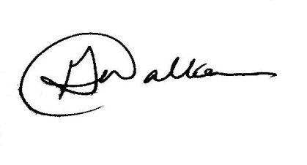
Fraternally,

Ill:. B:. Gerald Walker 33°
Commander in Chief

Ill:. B:. Clifford E. Hazel. 33°/96°
The Most Puissant Sovereign Grand Commander

